**SCHOOL OF ENGINEERING & TECHNOLOGY**

**ASIAN INSTITUTE OF ENGINEERING**

**THAILAND**



**INTERNSHIP REPORT**

Name - R.A.U.Dilhari Rajapaksha

ID - 20000494

Field - Civil & Infrastructure Engineering

**PREFACE**

This report is a brief presentation of knowledge and experience that I gathered during my internship period. The training period was 03 months at a proposed transit/duty free shopping area expansion at Bandaranayake International Airport, Katunayake site of Sanken Lanka (PVT) Ltd in Sri Lanka.

This report consists of the details of the company background and information relevant to construction work, an overall view of the establishment, the project and my training experiences classified according to the area of the work normally construction work and finishing work.

A general introduction has been given to that area, by describing the work of the particular section in the beginning. A general introduction has been given to that area in the beginning of describing the work of the particular section. Then I have presented the related construction details with procedures where necessary. At the end of most of the sections I have included tools and equipment required for each construction work.

I have gained some theoretical knowledge in the institute. But the expectation of this internship has been to familiarize us to the practical knowledge. My experience in this regard was basically related to the methods and practices adopted in the site. Thus in presenting my experiences of internship, a particular emphasis has been given behalf of me on practical consideration, than the theoretical aspect related.

**ACKNOWLEDGEMENT**

I would like to take this opportunity to express my gratitude to all the people who helped and advised me during my internship and during the preparation of this internship report.

I would like to record my deep gratitude and indebtedness to the **Asian Institute of Technology**, Thailand.

Also, I would like to take the opportunity to Mr. Sameera Jayawardana (Site Manager), Mr.Janaka (Engineer), Mr.Aravinda and Mr.Kasun (Assistant Engineers) Ms. Nadeeshani Kannangara (Quantity Surveyor), Mr. Muhammad Haniff (Assistant Quantity Surveyor) of the emperor project of Sanken Lanka (PVT) Ltd. It is with pleasure I thankful to all the staff members including our trainees in the site. I appreciate supervisors, sub-contractors and labors that help me to successes my training field.

I thank all of my friends and connoisseurs for giving their assistance to me during my internship and preparing the report.

Finally, I acknowledge my parents, who always back up me whenever there is necessary.

This period of internship is bound to be my next year academic education and I think this will be a prime to the vast Civil Engineering in the future.

Thank You,

R.A.U.Dilhari Rajapaksha,

Asian Institute of Technology (AIT),

Thailand.

Table of Contents

1.0 Background of company6

2.0 Project description9

2.1 Site Management

2.1.1 Introduction10

2.1.2 Management Structure of site 11

2.1.3 Monitoring of progress of the work13

2.1.4 Document at site 13

2.2 Store Management

2.2.1 Introduction14

2.2.2 Associated Notes with the Store15

3.0 Summary Of Duties19

4.0 Working Experience23

4.1 Demolition23

4.1.1 Breaking and Removing the Concrete Floors & Walls22

4.1.2 Breakers and Demolition Hammers25

4.2 Block Work

4.2.1 Introduction26

4.2.2 Mortar26

4.2.3 Blocks26

4.2.4 Material Used for Masonry Work27

4.2.5 Construction of Block Work27

4.2.6 Important Details of the Block Masonry29

4.2.7 Advantaged and disadvantages of Block Masonry29

4.3 Concreting

4.3.1 Introduction30

4.3.2 The Primary Operations of Concreting30

4.3.3 The Main Points Watch When Using Poker Vibrator32

4.3.4 Defects on Concrete33

4.4 Curing34

4.4.1 Curing Methods35

4.5 Plastering

4.5.1 Introduction35

4.5.2 Factors Were Considered Before Plastering37

4.5.3 Placing Guide Points 37

4.5.4 Equipment Use for Plastering37

4.5.5 Defects in Plastering38

4.5.6 Remedies for Plastering Defects38

4.6 Water Proofing

4.6.1 Introduction39

4.6.2 Water Proofing Materials39

4.6.2.1 Construction Joints39

4.6.2.2 Xypex40

4.6.3 Water Proofing Areas

4.6.3.1 Underground Water Proofing41

4.6.3.2 Toilets Water Proofing Work41

4.7 Painting

4.7.1 Introduction41

4.7.2 Primary Coat42

4.7.3 Under Coat or Body Coat42

4.7.4 Finishing Coat43

4.7.5 Instruments Used for Paintings43

4.7.6 Surface Preparation43

4.7.7 Method of Painting43

4.7.8 Technical Details44

4.8 Tiling

4.8.1 Introduction44

4.8.2 Important Considering Points When Laying Tiles46

4.8.3 Floor & Walls Tiling

4.8.3.1 Surface Preparation46

4.8.3.2 Tile Bed46

4.8.3.3 Tile Marking47

4.8.3.4 Applying Adhesive48

4.8.4 Granite Tile Installing49

4.8.5 Installing the Tile Skirting49

4.8.6 Grouting the Joints50

4.8.7 Equipments Used for Tiling50

4.9 Expansion Joints

4.9.1 Introduction51

4.9.2 Installation of Expansion Joints53

4.10 Ceiling

4.10.1 Introduction53

4.10.2 Metal Fiber Ceiling Tile54

4.11 Scaffolding Arrangements

4.11.1 Introduction55

4.11.2 Scaffolding Fittings56

4.12 Safety57

4.12.1 Safety Equipments Used in the Site57

5.0 Conclusion60

6.0 References60

7.0 Appendix61

**1.0 BACKGROUND OF COMPANY**

The Mitsui Construction Co. in Japan commenced operations in Sri Lanka in 1977, by the opening of a branch office in Colombo. Mitsui Construction Company Lanka (PVT) Ltd was established in May 1984, under FIAC authorization to take over civil construction work. In December 1985, the FIAC authorization was extended to include the leasing / hiring of industrial equipment.

In April 1988, Mitsui Construction Company Lanka (PVT) Ltd changed its name to Sanken Lanka (PVT) Ltd. The shareholders of company are Singha Holdings Ltd – 51%, Mitsui Construction Co Ltd – 39%; and Mitsui & Co Ltd – 10%.

In June 1988, Sanken Lanka obtained foreign construction work as well as to take over the employment of staff for such foreign construction work. Whilst in June 1988, the FIAC approvals were extended to cover the additional activities of the construction of Middle and Upper Class Houses as well as Commercial Complexes. Then in March 1991, approval was obtained for the sale of ready mixed concrete.

With the benefit of the Mitsui connection, Sanken Lanka has established itself over the years as a leader in the field of civil construction.

In May 2003, with the manager of Mitsui Construction with Sumitomo Corporation, there was a change in ownership, where the new shareholders were also the new Directors namely Messrs Mahen Weeraskera (70%), Ranjith Gunatileke (20%), and Yosuke Tahara (10%).

The company has a grade M1 for building construction. So it is the great qualification for award the massive construction tenders. In the past, there were some problems due to lack of building projects. Anyway now some projects are received.

Sanken Lanka has a good establishment of constructing, estimating, project planning and quantity surveying. However each of these functions is versatile and complex in nature and board perspective can be described as follows.

Planning of construction activities as completion the project within the target duration, estimating and controlling the recourse allocations.

Periodical monitoring of progress of work during the construction stage to identify any deviation from the set targets and taking remedial measures catch up on short falls.

Keeping in touch with inflow of funds, collecting advanced payment, retentions and value of bonds. Updating the contract value by adopting ICTAD specified price fluctuation methods.

Preparation of rate analysis for each activities involved in the construction industry using formal B.S.R., IDTAD statistics and research and work studies. Allocation of limited machinery, equipments, materials, direct labors to avoid the short coming and delays.

Collecting local rates from sub-contractors, which are having satisfactory labor force and engage them in construction site to gain the profitable service.

Vision of Sanken Construction (PVT) Ltd is to be Sri Lanka’s premier construction service provider. And mission is to provide a quality professional service, exceeding customer expectations, by the effective utilisation of all resources, with the best practice of the industry.

Aims and achievements of the organization are,

* To provide quality structures with modern finishes to the satisfaction of clients.
* To introduce quality ready-mixed concrete of recognized standards to the Sri Lankan market.
* To introduce latest construction equipment to the Sri Lanka construction industry.
* To promote technology in construction and equipments in developed countries.

And also scopes of business of the company are,

* To undertake complete projects from the investigation, planning and design stages to construction and commissioning under a single contract on a Turn Key basis.
* All types of interior decorations inclusive of walls, floors, ceilings etc.
* Construction of all types of industrial buildings ,schools, stadium, gymnasia, hospitals, airports, hangers, wharves, water supply schemes, drainage and sewerage works ,effluent treatment works, land reclamation, property development etc.
* To engage on property development schemes.
* To lease or hire concrete plant, machinery, scaffolding materials and construction equipment.
* To undertake the paving of color concreting work with different design.
* To undertake the supply, pumping and placing of ready mixed concrete.

Sanken Construction (PVT) Ltd is one of the leading Construction Company and RMC manufactures of Sri Lanka. The severity of pollution generated by construction and RMC manufacturing processes are identified and therefore they are fully committed to reduce all the significant environmental impacts resulting from our activities, products and services by incorporating recycle, recover and reuse options to provide a better, cleaner and safer environment for sustainable development. The company is putting best efforts for success establishment, implementation and maintenance of Environmental Management System (EMS) according to International Standard ISO 14001:2004 to achieve their goals.

**SANKEN LANKA (PVT) LTD.**

No. 295,

Madampitiya Road,

Colombo 14,

Sri Lanka.

Tel: +94-11-2522933339-41

Fax: +94-11-2522942

**Company Registration No** : N (PVS) 1109

**Date of Registration** : 23-05-1984

**2.0 PROJECT DESCRIPTION**

Name of this project is transit/duty free shopping area expansion at Bandaranayake International Airport at Katunayake in Sri Lanka. Spread over 1500 m2 in the departure section of the Katunayake airport.

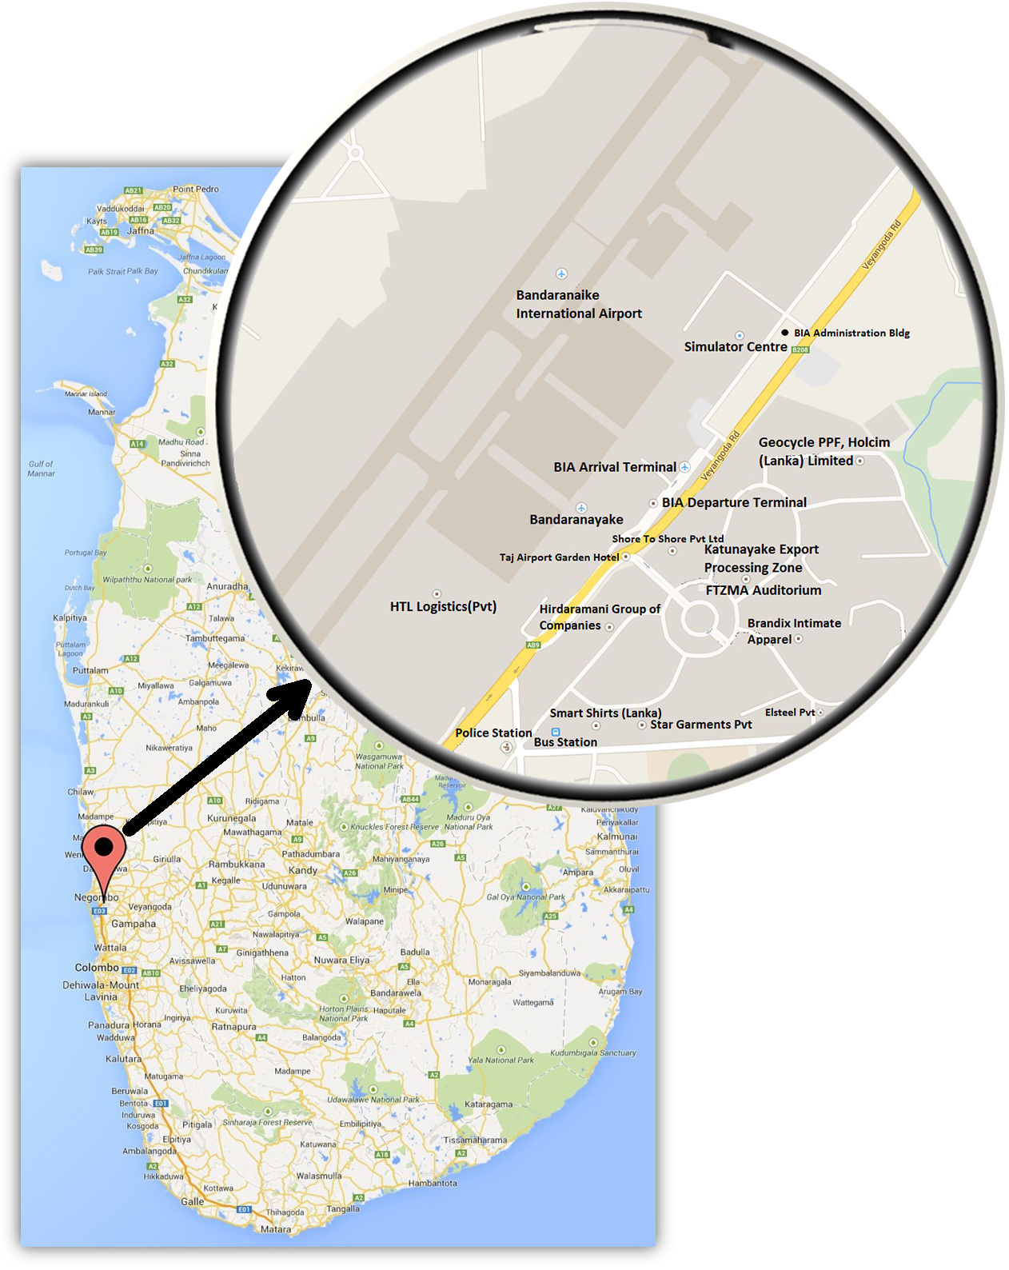

*Fig.01: map of the Katunayake airport Sri Lanka*

The client is Airport and Aviation (Sri Lanka) Ltd. The main contractor is the Sanken Construction (PVT) Ltd. And other constructions were done with the subcontractors for labors, painting, plumbing, tiling, ceiling works etc.

The project was been commenced on February of 2014 and the duration of the project is 7 months. The estimated cost of the total project was 74,843,198.00 rupees.

[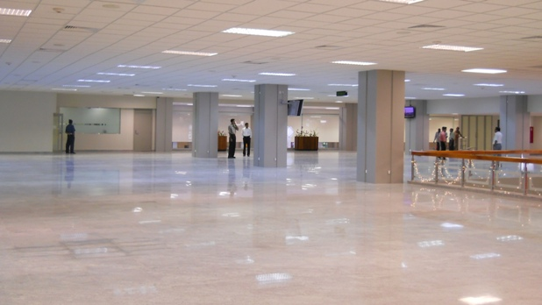](http://www.sankenconstruction.com/projects/129/main.jpg)

*Fig. 02: Expansion project of Katunayake airport Sri Lanka*

**2.1 SITE MANAGEMENT**

**2.1.1 INTRODUCTION**

Management, It is very important factor in any kind of work. The process of interconnection of main functions such as planning, organizing, controlling, and leading are called as site management. These things are managed for the achievement of objectives and goals of the projects.

It is important to have proper management at any construction site to carry out works in an economical material. The method of caring out successive operations and selection of general management of any site are considered as important points to have best management study of all aspects of the work form, because of the construction works are carried out with given designs and specified

### 2.1.2 MANAGEMENT STRUCTURE OF SITE

Organization structure of the proposed transit/duty free shopping area expansion at Bandaranayake International Airport at Katunayake in Sanken construction (PVT) Ltd. is as follows,

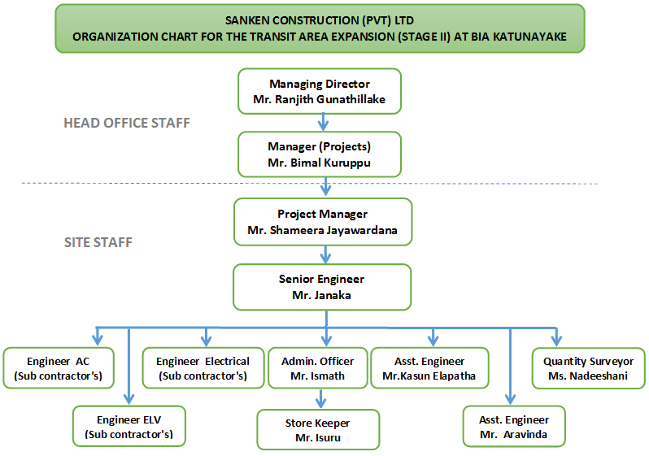

Duties and responsibilities of these officers at the proposed transit/duty free shopping area expansion at Bandaranayake International Airport at Katunayake site distributes as follows,

Project Manager - Mr.Shameera Jayawardana

Project manager is the person who has to communicate with head office and site manager.

* Advising the client at beginning of the project on financing and land acquisition, preparing the brief and appointment of consultant and contractors.
* Planning, controlling and directing for the client.
* Responsible for all section of the technical, administration and the other parts.
* Preparation of program and progress charts for the site.
* Coordinates between head office and site between the client and contractor.
* Coordinating with different sub-contractors agencies to maintain the progress of construction project work.

Site Manager – Mr. Janaka

It is important that the Site Managers should maintain construction documents such as weather reports, concrete pouring charts, drawings etc. And also he should update daily work approval sheets, information of labor, machineries, tools and progress of the previous day work.

* Maintain attendance register
* Administrative function of the site engineer
* Store control
* Site security
* Cash disburse
* Maintain disciplinary at the site

Engineering Staff

This group consists of engineers, assistant engineers, technical officers and training engineering staff. They have to check the all works with technically which are undergoing their section. Material requisitions are approved and checked the material consumption. They should assure that the work is carried out according to the details in construction drawings and specifications and prepare reinforcement schedules of the project. Attend the daily site meeting and discuss about the problems uncounted in the site.

Administrative Officer - Mr. Ismath

He is the person who is responsible for every administrative work in the site. He is instructed by site manager. He always contact with the administrative section at head office. In addition, he is responsible for preparing of sub-contractors bills and other bills and as follows,

* Security services should be carefully checked on daily basis and report promptly all shortcomings to project manager.
* Keep well assistance with storekeepers to find out requirement to store daily.
* Maintenance and movements of machineries vehicles and arrange it requirement in time.
* All the copies of attendance sheet and any other documents pertaining to employees form be carefully packed and dispatched to need office at the end of every month. Every personal accident looks after the purpose of employee and he should take action.

### 2.1.3 MONITORING OF PROGRESS OF THE WORK

Progress of the work is monitored with the work proceeds according to the program. This leads to work according to the program and to show the delays of work and then arrange to do quickly.

Site meetings, participating client, architect, contractor, subcontractor, and consultant are held to discuss the progress and the present situation of the site. For this meeting site manager, have to prepare weekly progress report, and monthly progress reports.

### 2.1.4 DOCUMENTS AT SITE

When we join in a construction work, always we have to check the dimension and quality of the work and progress of work. For this work, we have to refer some documents at site,

* Details drawings
* Bills of quantities
* Specifications
* Method Statement

**2.2 STORE MANAGEMENT**

**2.2.1 INTRODUCTION**

In every construction site has good stores. The site progresses depend on the behavior of the site stores. Store management is the important thing in a working site. All the wanted things for each every section is coming through the stores. To get good store handling without wasting the materials or working hours or labors due to the finishing of material of the site manager should keep close associated with storekeepers.

To keep the stocks in order there are several types of books are used to record those details. These books and documents should be maintained clearly and daily. In this site stores daily issued goods are entered in a stock books and the balance stock of the each day is maintained to get the idea about the amount of goods in a stocks. Some other goods like wire brush, sprite level, center plumb bob, level machine etc. are issued to workers after sign in the temporary issued book. The material quantity of next week will be order by using the material requisition from in every week. All daily materials are issued by using the material requisition.

## Role of Store Keeper

* Maintaining stock cards (consumable & non consumable)
* Controls/ checks quantity & quality of materials delivered.
* Prepare daily or monthly records for materials received at site.
* Inventory control of plant, machinery and equipment their usage at site & maintaining records of repairs & services.
* Ensure adequate inventories & stocks are available to meet the site planned activities.
* Prepares GRN (Goods Return Note)
* Prepare material reconciliation report
* Prepare goods issued note
* Prepare transfer notes for material transferred out from the site.

Material Control Reports

The material control report which is a list of various records of materials transactions contains how to maintain the logistic report list in each individual transaction of materials received, transferred & issued. The logistics department which keeps all reports, is the main tool used to keep track of the material flows in the project. The department should responsible to maintain all documentation needed in the project in terms of materials in the department.

**2.2.2 ASSOCIATED notes with the store**

* G.R.N.-Good Received Notes
* D.N-Dispatch Notes
* T.N.-Transfer Notes
* D.A.-Delivery Advises
* Req. N- Requestor Notes
* Bin Cards
* Gate Passes

G.R.N - Good Received Note

At the time of requested materials are received to the storekeeper, by checking quantity received, the storekeeper prepared the material & good received note. And the quality of the materials or service (machines) received thoroughly, is checked by the technical officer. Finally appointed officer in charge must give the final approval.

Internal Use Only

***SANKEN LANKA (PVT) LTD.***

SL/PD/GR/001

***GOODS RECEIVED NOTE***

DATE: STORE CODE: GRN NO: 15750

To: ………………………… Received From: ……………………

Supplier Invoice / Supplier Delivery / Sanken Gate Pass No: …………………..

|  |  |  |  |  |  |
| --- | --- | --- | --- | --- | --- |
| Item NO | Description & Specification | Unit | Qty | Value | Remarks |
|  |  |  |  |  |  |
|  |  |  |  |  |  |
|  |  |  |  |  |  |
|  |  |  |  |  |  |
|  |  |  |  |  |  |
|  |  |  |  |  |  |
|  |  |  |  |  |  |
|  |  |  |  |  |  |
|  |  |  |  |  |  |
|  |  |  |  |  |  |
|  |  |  |  |  |  |
|  |  |  |  |  |  |
|  |  |  |  |  |  |

|  |  |  |
| --- | --- | --- |
| Goods Handed Over By ;  Signature: ………………….  Name: ……………………...  ……………………………...  NIC / DL NO: ……………...  Vehicle No: ………………..  Time: ………………………  Date: ………………………. | Security:  ………………………….  Signature (Security Officer)  Stores:  ………………………….  Signature(Store Keeper)  ……………………………..  Name | Items received in acceptable condition  ……………………………..  Signature(Site Manager)  ……………………………..  Date |

M.R-Material Requisition

This note will get with the certification of an officer before issue material from stores. This notice is very imported to prepare the purchase requisition and to calculate the reconciliation of materials.

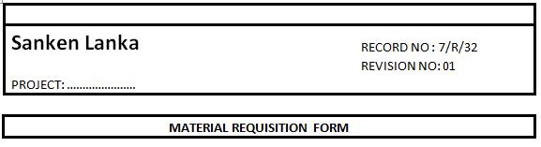

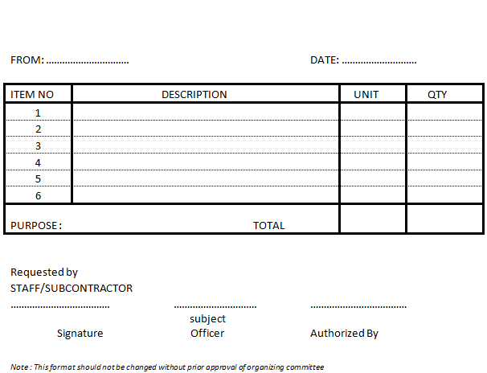

Stores Material and Service Requisition

Storekeeper should informed to the site manager or admin officer if material is not available or not in sufficient quantities in the site. To transfer purchasing through the office store requisition is prepared. Then it is certified by the site manager and forwarded to the head office.

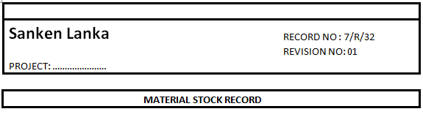

Sheet No: ……………

Item: …………………

Description: ………….

|  |  |  |  |  |  |  |
| --- | --- | --- | --- | --- | --- | --- |
| DATE | INVOICE / G.P REQUISTION NO | RECEIVED QTY | ISSUED QTY | | BALANCE QTY | REMARKS |
|  |  |
|  |  |  |  |  |  |  |
|  |  |  |  |  |  |  |
|  |  |  |  |  |  |  |
|  |  |  |  |  |  |  |
|  |  |  |  |  |  |  |
|  |  |  |  |  |  |  |
|  |  |  |  |  |  |  |
|  |  |  |  |  |  |  |
|  |  |  |  |  |  |  |
|  |  |  |  |  |  |  |
|  |  |  |  |  |  |  |
|  |  |  |  |  |  |  |
|  |  |  |  |  |  |  |
|  |  |  |  |  |  |  |
|  |  |  |  |  |  |  |
|  |  |  |  |  |  |  |
|  |  |  |  |  |  |  |

*Note: This format should not be changed without prior approval of organizing committee*

**3.0 SUMMARY OF DUTIES**

During the working period at transit/duty free shopping area expansion at Bandaranayake International Airport at Katunayake in Sri Lanka I gained a lot of practical knowledge & working experience about construction engineering. I did much work in this site and a list of these works with a brief description is shown below:

* Monitoring demolition works in the old building. It is done with using an electric heavy duty breaker.

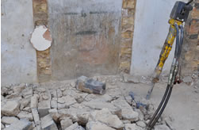 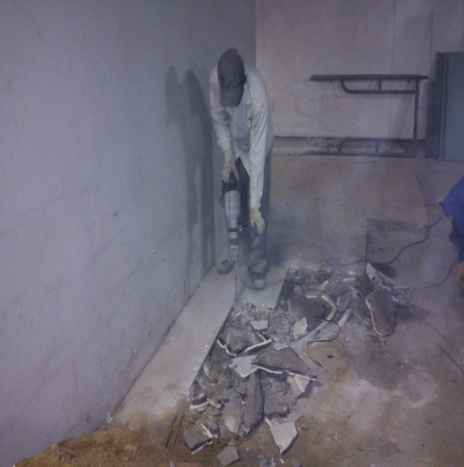

*Fig.03 & 04: demolition work*

* Monitoring the block work in the site. In some areas in the site, it is wanted to build some walls or part of the wall. In our site, it is used hollow blocks which have 200mm width. And it is used cement mortar, prepared by mixing cement and sand in 1:5 proportions with adding water.

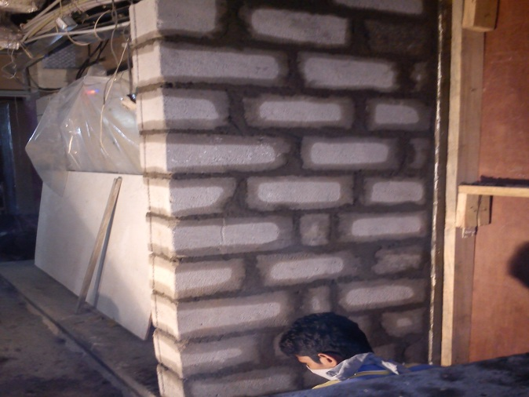

*Fig.05: block work*

* Monitoring the concrete work which used to construct the concrete stage to keep the electric panel.

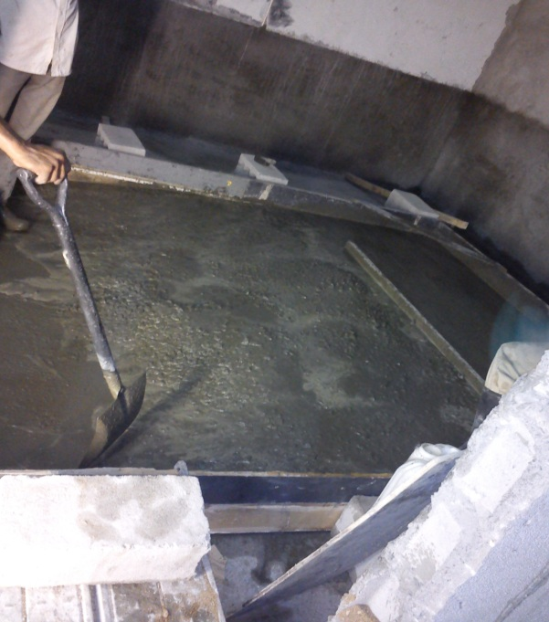 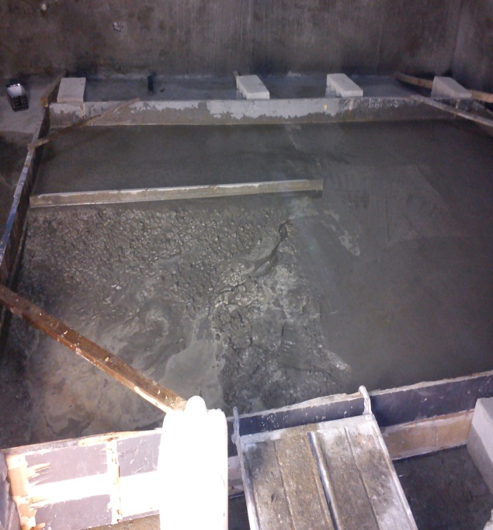

*Fig.06 & 07: concrete work*

* Checking the curing work. After concreting the floor, it should be kept 2 or 3 days to curing.

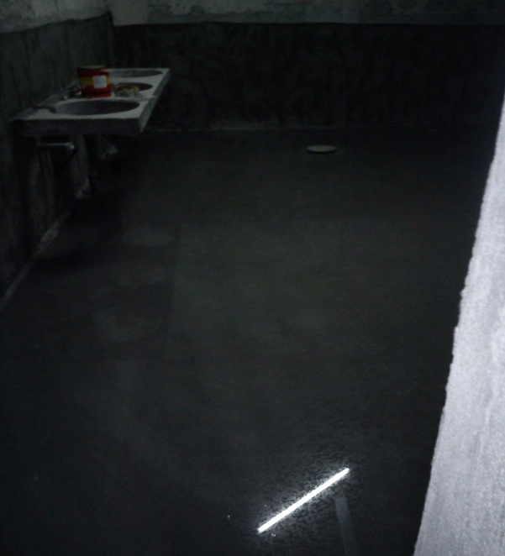 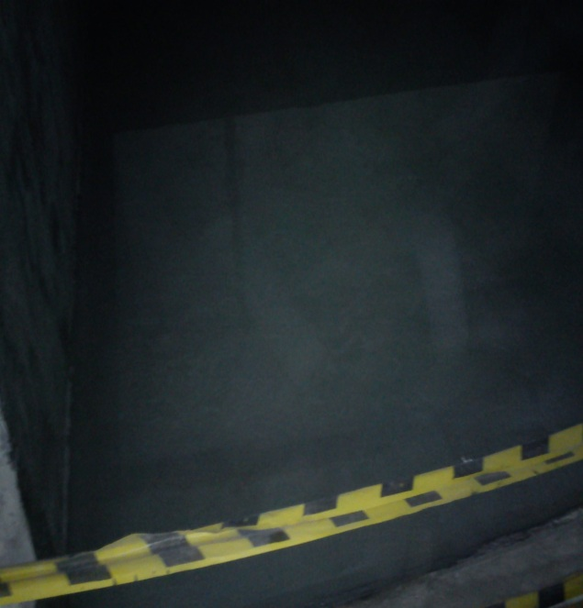

*Fig. 08 & 09: curing*

* Monitoring the plastering walls. After block work, cement plaster is used as the protection of wall. In my site it is used cement and sand with 1:5 ratios.
* Monitoring the painting works. In my site, it is applied pre-coat layers on plastered wall. After one layer of pre-coat it should be smoothed the wall using sand papers. Then it can be applying filler on the wall. After doing this work some times to remove the patches on the wall, it can be applied color paints.

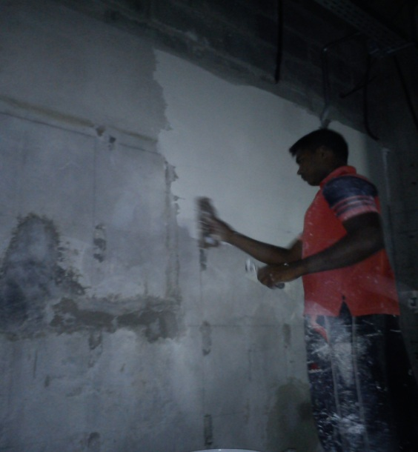 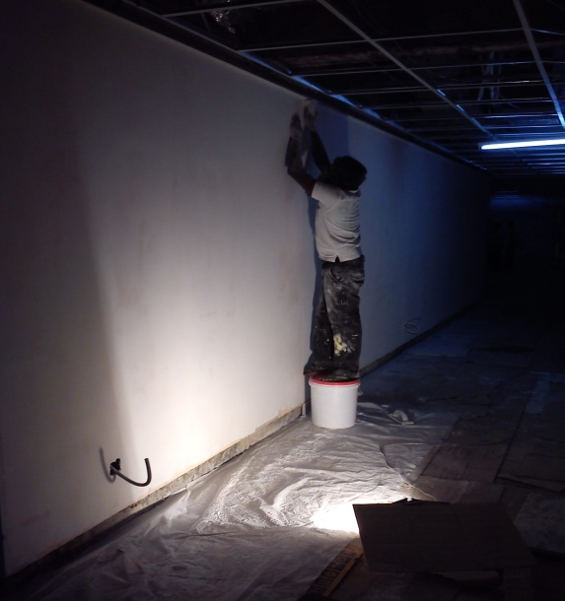

*Fig.10: applying pre-coat Fig.11: smoothing wall*

* Monitoring the tiling work. In our site, it is used wall and floor tiles and granite tiles.

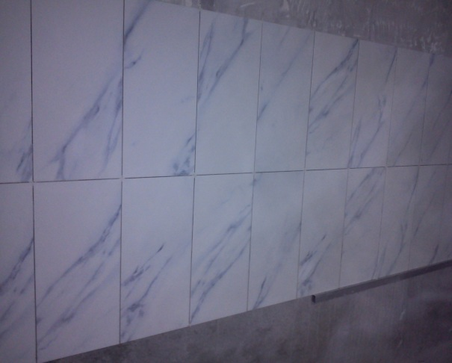 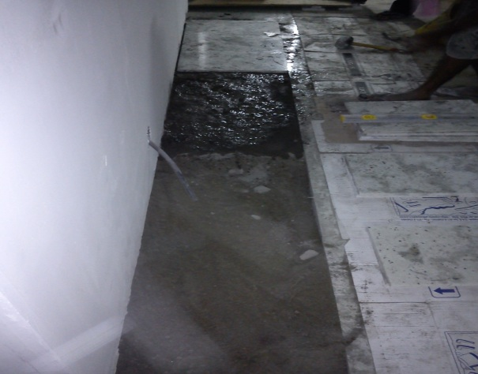

*Fig.12: wall tiling Fig.13: granite tiling*

* Checking the expansion joint construction. Using grinder, it is made a drain which has 20mm width & 40mm depth. Then it should be cleaned the drain until removing the dust and then put the closed cell polyethylene joint breaker rods in to the drain and push down. After that it is applied primer on two walls of drain with using small brush. And then, poured the sealant on the rod until remaining the 10mm (half of the width of the drain) from the top level. Then it can be installed the expansion joint cover plate and kept some weights on it to stick well.
* Monitoring the ceiling work. In my site, it is used aluminum T-bars as ceiling frames. As well as in bath rooms it was used aluminum ceiling sheets and other parts it was used metal fiber ceiling sheets.

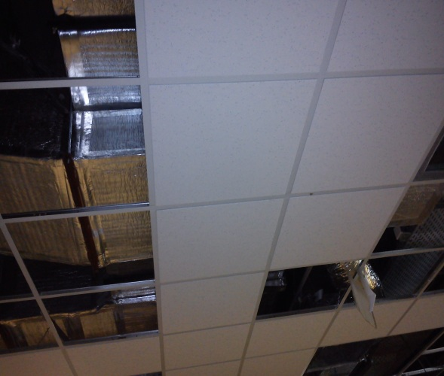 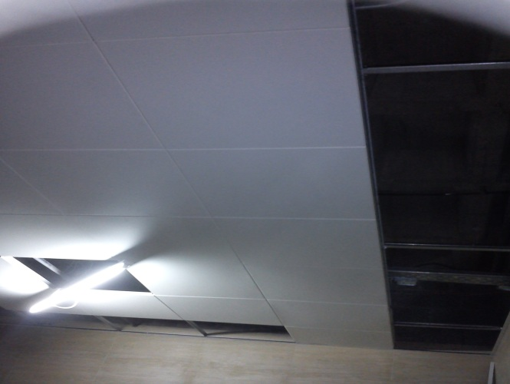

*Fig.14: metal fiber ceiling sheets Fig.15: aluminum ceiling sheets*

* Checked the finishing works in bathrooms like sensor tape, tank fitting and toilets installation etc.

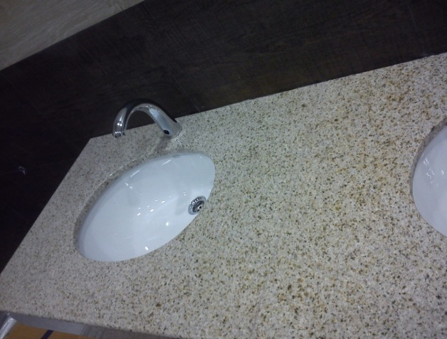 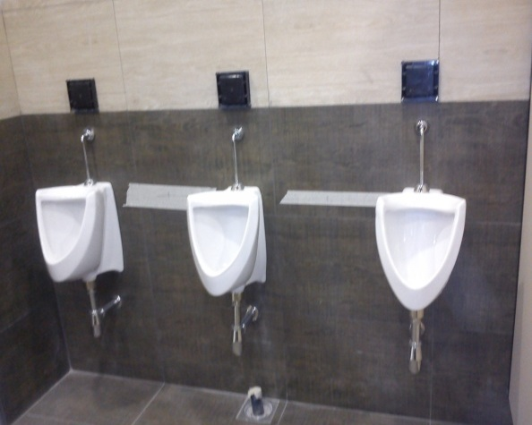

*Fig. 16 & 17: sensor taps and toilet fittings*

* Measured and prepared the measurement sheets for granite tiled areas, painting areas etc.

**4.0 WORKING EXPERIENCE**

In this expansion project, I got over all knowledge about demolition works and finishing works.

**4.1 DEMOLITION**

In this site it has to demolish many concrete walls and floors. In here, it will be needed to use powerful equipment and always take proper safety precautions when doing demolition of concrete floors and walls because concrete is very stable and hard to remove.

**4.1.1 BREAKING AND REMOVING THE CONCRETE FLOORS & WALLS**

Before using tools to breaking concrete, it has to wear safety equipment. Power tools are required to this section which will be working with rough materials, so it is necessary that workers keep protected.

Earplugs, a hard hat and safety goggles should be wanted to wear. It is important to protect ears and head where tools will be used to break up concrete can be very noisy and could actually cause pieces to fly up from the ground. To avoid inhaling dangerous substances, it will also need to wear a face mask both to protect the mouth. And also, it should be wanted to wear tough boots and tough clothing with long sleeves and legs to protect skin. The workers who will be handling rough pieces of concrete should be aware of and protect from loose debris.

And if there any services such as electricity, water, gas, communication cables etc. running below or near the concrete floor or wall to be broken up, so it should be identify potential risk areas and determined. It should be completely cleared if there are any of these.

It is a best way to remove large concrete parts which is to break it up into several smaller pieces. And this makes not easier to remove the concrete but also to makes it easier to discard the old floors & walls.

The best way to start at the side that is farthest away from worker so, to break the concrete, it should be stand on the solid, flat concrete that hasn’t been broken yet.

It is started with the point of the breaker touching the cement and then switches the tool on. The tool vibrating will be getting started because of hammering the point into the cement hundreds of times per minute.

Holding the breaker firmly and upright and let the point crack and break the surface of the slab is extremely important that workers have a solid place to stand and that have good footing while they are using the breaker. It should be held the tool firmly and perfectly upright. If its’ don’t, it may begin to move to one side or the other and become harder to control. When this same problem also be appear and if it is applied too much pressure to it, so hold it firmly, but do not push down on it too hard.

And it is very important to work slowly and carefully and let the breaker do the work and also rushing or trying to force the tool into the concrete can be dangerous. It should be never push the breaker into the concrete in a diagonal direction or use it as a lever because this could cause damage and could be dangerous. And also it is very important to keep the power cord behind the work place and is not near the point of the breaker.

If a good tip is to look for cracks and broken pieces of concrete and work the breaker along that then this will make it much easier to break up the concrete. It can also be helpful to pause periodically and remove concrete debris.

The best approach is to break the concrete up in the pattern of a grid and as long as they are small enough to remove and discard of. It can be broken up into any size of pieces as necessary.

Whenever the breaker is turned off, it should be held until it is completely turned off and no longer moving before putting down it.

It can be used a wrecking bar to break it into even smaller pieces where necessary after broken up the concrete floor. Then, a shovel is used to scoop the concrete pieces into a skip and a push broom to sweep up smaller pieces and dust.

With using a heavy-duty breaker, concrete breaking and removing is large works and it can be done with the right tools, safety precautions and some planning.

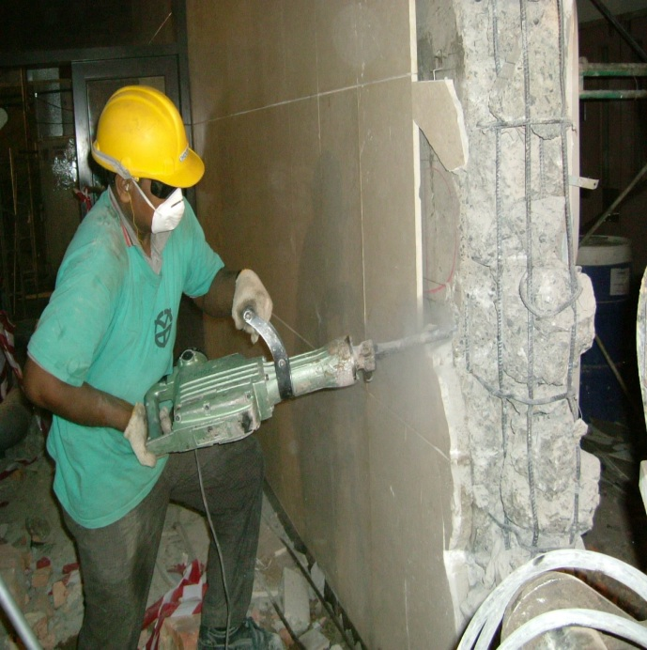

*Fig.18: Concrete breaking*

**4.1.2 BREAKERS AND DEMOLITION HAMMERS**

The nature of concrete is so strong and when using breakers are the only real way of cutting up into manageable size pieces it can be easy to clear. There are number of different breakers available as jackhammers. A builder would use a hydraulic breaker or a pneumatic breaker powered by a compressor typically. An electric heavy duty breaker would be more appropriate for DIY.

It can be used to break up concrete walls lighter weight demolition hammers and the like but, need a heavy duty breaker for concrete floors. These machines deliver around 1000 blows per minute enabling the slab to be broken up effectively. Machines are often 110 volt so you will be supplied with an appropriate transformer as well.

The breakers have two parts as point and chisels. Chisel is used to breaking up the concrete floors and walls. Changing the steel blade is a straightforward process. It is very important to make sure that the machine is switched off and disconnected from the power supply and open the chuck by lowering the lever.

The old steel is removed and the new one is simply inserted as far as it will go. Then the chuck is closed by returning the lever to its original position.

Breakers work by delivering a hammer blow to the top of the point or chisel then repeating the process hundreds of times per minute.

**4.2 BLOCK WORK**

**4.2.1 INTRODUCTION**

In our site block masonry was used to construct walls. Block walls may be partition walls or load bearing walls. Block masonry work is done by laying one block on another block by means of the bonding agent. This bonding agent and the blocks should be strong enough to give stronger walls. Motor is the commonly using bonding agent. So the block and the mortar are the most important items of a block wall.

**4.2.2 MORTAR**

Mortar is mixture of cement & sand. It is used for to bind the individual blocks to form the whole wall a compact mass. It can have many kind of in various proportions. In our site it is used 1:5 cement and sand for walls. Mortar is mixed by hand or mortar mixer, in our site used hand mixer.

**4.2.3 BLOCKS**

There were two types of cellular blocks whose dimensions were 200mm x 190mm x 390mm and 100mm x 190mm x 390mm (hollow blocks). Blocks were made of cement and aggregates mixed in correct proportions with relevant SLS certificates. Blocks are extensively used for both load bearing & non load bearing walls.

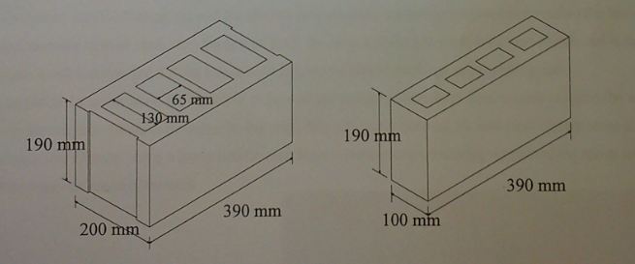

*Fig.19: hollow blocks*

**4.2.4 MATERIAL USED FOR MASONRY WORK**

* Blocks
* Masonry trowel
* Center plumb bob
* Sprite Level
* Aluminum level bar
* Measuring tape
* Shovel
* Mortar pan
* Tri square

**4.2.5 CONSTRUCTION OF BLOCK WORK**

When constructing a wall, two blocks were carefully laid and aligned vertically according to mason’s plum bob. To align them horizontally 200mm offset was used. The block was aligned horizontally using measuring tape by placing it correctly so that the distance between the block and the offset was 200mm. (As the Figure, X and Y distances should make 200mm by placing the block correctly).

A

B

200 mm

200 mm offset

Wall construction lines

100

*Fig.20: Blocks A and B are the extreme blocks of the wall*

*Fig.21: Vertical Leveling*

Elevation

Mortar layer

BLOCK

Plan

*Fig.22: Horizontal Leveling*

200 offset

X

Y

BLOCK

After correctly leveling the blocks, two strings were smoothly fastened connecting the two blocks in order to lay rest of the blocks in the row. In each layer, mason’s plum bob was used to ensure the verticality of the wall.

Strings

Slab

Elevation

*Fig.23*

**4.2.6 IMPORTANT DETAILS OF THE BLOCK MASONRY**

* The slab area should be chipped, (if smooth) cleaned and wetted on which the wall is built before the work start. A layer of cement grout is then applied on the slab area and also on the sides of columns which would be bound by the wall to ensure a sound bonding with the brickwork.
* It is very important that the first course, which generally is a stretcher course, is laid on a ½” thick layer of mortar applied over the grout layer and two bricks are placed in the corner point wall. Both cross-joints and bed joints should generally have a thickness of about 10mm, which is ensured inserting fingers between the bricks for bed joints.
* The plane of strings is horizontal the top level and line of a brick of a particular course can be given with the aid of two strings drawn temporarily in such a way.
* It is very important that the work can proceed raising the corners in a step manner up to about 5/ and filling the balance after that. Otherwise the whole wall can be raised as one particular unit.
* When it is absolutely necessary for obtaining the specified bond, no block bats should be used in the work except.
* A good quality of a specified mortar should be used in the work and taking great care that uniform mortar joints is obtained throughout the construction. It is very important that the thickness of joints should not exceed 13mm in any case.
* The wall is stopped with a toothed end when it is desired to increase the length of the wall under construction at a future date. It is necessary to ensure continuous bonding between the old and the new work.

**4.2.7 ADVANTAGES AND DISADVANTAGES OF BLOCK MASONRY**

Advantages Of Block Masonry.

* Labor saving. (Easy to cut, larger units)
* Easy to fix.
* Super-fast construction.
* Higher thermal insulation properties.
* Stretched both provide suitable key for plaster and cement rendering.

###### Disadvantages Of Block Masonry.

* Due to shrinkage can be cracking easily.
* Can’t handle easily.

**4.3 CONCRETING**

**4.3.1 INTRODUCTION**

Concrete consists of sand, gravel and stone which can be called as coarse and fine aggregates and a bonding agent which bonds all the above mentioned substances and leads to a composite substance. The bonding agent mostly used in construction industry as the paste of cement and water. Mainly it fills the voids among aggregates and also it provides lubrication to the freshly mixed concrete. In the ultimate state this causes the concrete to gain strength.

In such a way, the concrete should be selected that is suits to the purpose. In selecting, combining and mixing materials should be complying with the purpose which needs special qualities of the concrete. Ordinary Portland cement is the most commonly used cement in concrete. And the bulk of volume of concrete is aggregates which provide cheap filling material for the cement paste, resist abrasion and wear and reduce volume changes in the process of hardening.

**4.3.2 THE PRIMARY OPERATIONS OF CONCRETING**

* Batching

Concrete for usual purposes would have a mix determined by arbitrary standard, and for work involved in greater importance the mix could be designed, usually the coarse and fine aggregates are taken in the proportion of 2:1 and the popular types of mixtures are 1:2:4 and 1:3:6 the proportioning of materials should be done by either volume or by weight. But rather than volume of cement and aggregate varied with the degree of compaction and also in case of sand due to bulking. And also, batching is done by mechanical means for the ready-mix concrete.

* Mixing Of Concrete

The cement, sand and aggregates are mixed such that the ingredients are uniformly distributed in the concrete mass. There are two types of concrete mixing namely,

* Hand mixing
* Machine mixing

*Hand Mixing*

The hand mixing is done on a level, clean and non-porous floor or board. Firstly the sand measured and spread on the board in a layer and required cement is spread on it the above mentioned proportioned. Two men mix these two materials with using shovels. And the whole ingredient is mixed thoroughly as evenly as possible. Then the water is spread gradually and shoveled. The whole mixture is turned over in this manner at least 03 times while dry and again at least 03 times while water added. If water is added at once the portion of mix dry. Therefore it must be taken great care to ensure that the whole mix uniformly absorbs the added water.

*Machine Mixing*

The machine mixing is the speed of rotation of the drum and the duration of mixing affect the quality of concrete.

* Transport Of Concrete

Concrete should be transported where it has to be placed as rapidly as possible by a method, which prevents the segregation or loss of ingredients. When concrete have to be lifted for high-level differences, Hoist machine was used for it.

* Placing And Compacting Concrete

The main thing, which should be taken care in placement of concrete, is to ensure that initial setting has not started. This time for ordinary Portland cement is 45 minutes. When it is put concrete in to the big area of a slab or a base, it is done part by part. If the first concrete sample was put in to the one place, second sample must be put little bit far away, then the third one to be done in the same way. It is very important to remember, before passing the initial setting time the next concrete sample should be placed in to above places. The ultimate strength of the concrete is increased by proper placement. Manual system or pumping system is used for the placement of the concrete. Whatever the method which is adopted, it should be confirm that the continuity supply of the mix during the placement of the concrete.

To achieve maximum strength the concrete must be compacted. Compaction of the concrete is achieved by vibrating it in to fluid state. This realizes the trapped air, allowing it to move upwards and escape at the floor. It is used porker vibrator for concrete compaction. When compaction is done using the poker vibrator it should be inspected to get the maximum possible compaction without any segregation. When the concrete become the sound of vibration will change.

**4.3.3 THE MAIN POINTS WATCH WHEN USING PORKER VIBRATOR**

* Make sure that the all area is covered adequately.
* The porker is moved frequently, a little and always in one area is better than holding it in one place for a long time.
* The porker must be withdrawn slowly and if not it can form a pocket entrapped air.
* Do not touch the forms because any marks in the forms will make a mark on the finished concrete surface.
* Do not compact the layer of concrete more than 2’’ thickness with porker, because air has to be forced to the surface and porker is unable a greater depth than this.
* Push the porker in to the lower layer when compact layer of concrete on top of another layer that is newly placed. This prevents the bringing of any noticeable difference for compacting between the two layer and join them together effectively.

Start compacting at bottom of the slope.

**Correct**

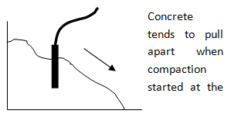

**Incorrect**

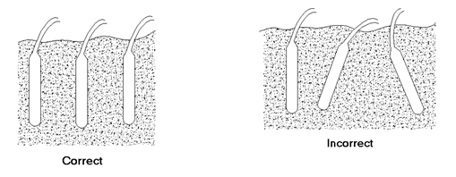

*Fig.24: methods of using poker*

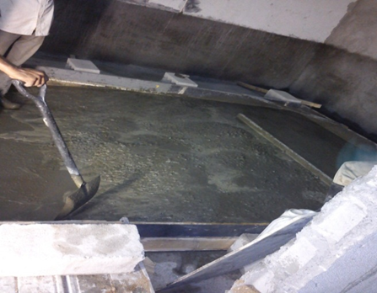

*Fig.25: concreting work*

**4.3.4 DEFECTS ON CONCRETE**

Because of some incorrect methods several defect have been found on the concrete surfaces. These defects decrease the strength of the concrete. it should be tried to decrease these defects.

* **Honey combs**

This is cause due to mortar in concrete leaking out between form works and compacting was not properly done. So it should tighten shutter boards and seal openings. Also compacting should carry out correctly

* **Cold joints**

Firstly concreted places will be setting early when a large area is concreted. And the next turn of concrete is coming there is already hardened edge and the overall slab or beam is not continuous from that joint. This joint is very week since the joint is not vertical.

* **Pinholes on vertical surfaces**

Concrete not well tamped against the shutter depth of the concrete should be sufficient.

* **Color difference of concrete**

This is occurred due to difference in porosity of timber. So it has smooth forms at some places. Do not use wet forms and boards same number of times. Slight roughness plywood forms are good.

**4.4 CURING**

The chemical action between water and cement that result in the setting and hardening of concrete is depending on the presence of water. Although there is normally adequate quantity of water for full hydration at the time of the concrete is prepared, it is important to confirm that water is either retained or replenished to enable the chemical action to be continued till such time for required strength is gained. Maintaining an environment in high humidity around fresh concrete is known as the curing process of concrete.

Curing has a strong influence on various properties in concrete such as strength, durability, water tightness and volume stability. Concrete lose water due to evaporation of water by the wind and the sun.

**4.4.1 CURING METHODS**

* Ponding – the flat surfaces such as floor slabs and deck slab of culverts can be cured by using this method. Ponding water lost due to evaporation should be continuously replenished. Entire area must have to be covered by water.
  + - * + Wrapping wetted sags –This method can be used for any concrete surface. Specially used for columns.
        + Spraying Water –This method can be used for both horizontal and vertical surfaces. There should be continuous water supply.

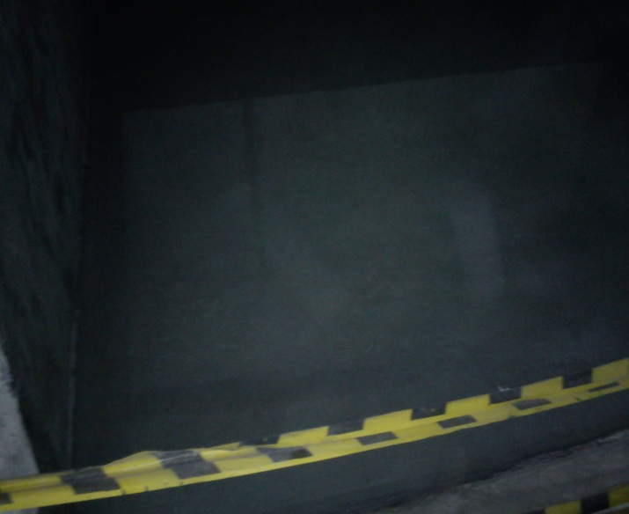

*Fig.26:curing the slab*

**4.5 PLASTERING**

**4.5.1 INTRODUCTION**

The function of plastering is used to protection of wall and the appearance of the building. Plastering was the art of covering to surfaces with a plastic material to obtain an even, smooth, regular, clean and durable surface. There are various types of plasters used. In my site cement plaster was used. Ratio of mixture of the cement plaster is 1:5cement: sand. Usually thickness of plastering is 15mm.

The principle objects of plastering were,

* To provide a true, even, smooth and finished surface to the work and improve the appearance.
* To protect the surfaces from harmful effects of atmospheric influences
* To cover up unsound and porous materials.
* To cover defective workmanship.
* To give suitable ground for white wash, color wash, distemper or paint.

Plastering covers the defective workmanship and covers up unsound and cheap quality material. Always, plastering was required to provide a satisfactory base for decorating the surface by whitewashing, color washing, distempering or painting. External plastering also named as “rendering” was done with the object of improving the resistance of the surface to rain water penetration and other atmospheric influences.

The following factors are affected the selection of the type of plaster to be used:

* + - * + Availability of binding materials.
        + Desired durability and finish.
* The place where the plaster is going to be used.
  + - * + Atmospheric conditions to which the plaster would subject.

The plasters normally contain a binding material, fine aggregates and water. Sometime, special additives are mixed into the plaster for improving the appearance or the adhesion.Plastering can be divided two categories,

* Internal plaster -

A smooth surface is provided by the internal plastering, in which dust and dirt are liable to adhere much. And also the surface is not affected by vermin and forms a good base for applying color wash, distemper or paint.

* External plaster -

Covering the surfaces is the main object of external plastering which protect from rain and other weathering agencies besides concealing defective workmanship and inferior materials.

**4.5.2 FACTORS WERE Considered Before Plastering**

* Cleaned the selected area without timber parts & nails.
* Removed honeycombs at the wall.
* Chipped extra concrete surfaces & loose concrete particles
* Tirod holes are filling from polyform on the wall for plastering. Then applied the chemifix to them.
* After doing that, leave those holes about 5 min. then using 1:2 cement: sand mixture for close them.
* Placed chicken mesh to edges of connecting of block wall and concrete wall.
* Finished Electrical & plumbing work.
* Removed oil or paint surfaces.
* Accreted all doors & windows position
* The walls must be well washed, cleaned and kept wet for at least one hour before the plaster is applied.

**4.5.3 PLACING GUIDE POINTS**

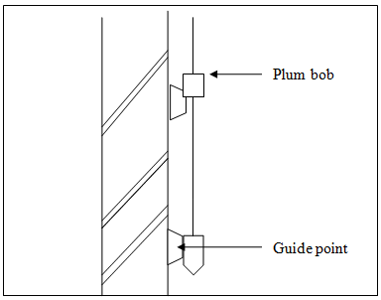

*Fig.27: Method of placing guide points on plumb out walls*

**4.5.4 EQUIPMENTS USE FOR PLASTERING**

**Level Bar:** Level Bar is used to make surface vertical. It is used to checked plaster whether it is finished correctly. It should be long enough to keep between two gauges. And it should be straight.

**Tri square:** Tri square is used to check the revels and corners of plaster. Using it can make right angles in corners for checked plaster finish.

**Plum Bob:** Plum bob is used to maintain vertically during block. In internal plastering work is used to make spot level gauge and level preparation also. But in external plaster we don’t use it.

**Sponge Piece:** Sponge piece are used to make final plaster using this make a smooth surface.

**4.5.5 DEFECTS IN PLASTERING**

**Cracks: -** Plastered surface may be developing cracks that may thin hairline cracks, or wide open cracks. If the cracks are not easily noticeable, they are not considered as defects. The development of thin hair cracks is known as “crazing” and it may be due to some reasons such as,

* Finished surface being very smooth, normally rough finished surfaces cracks less than smooth finished surfaces.
* Excessive thickness of plasters causing excessive shrinkage.
* Expansion or shrinkage of the plaster itself during drying.
* Movement due to expansion or shrinkage of backing materials.

**4.5.6 REMEDIES FOR PLASTERING DEFECTS**

To minimize defects, the following measures should be employed,

* The surface which have to plastered should be properly prepared and well watered before the plaster is laid over it. This is help to prevent absorption of water from plaster.
* The finished surface of the plaster should not be toweled excessively.
* The quality of the blocks used for construction must be good.
* It has to use the water that free from soluble salt.

Alternatively a solution of 1 part of hydrochloric or sulfuric acid with 4 or 5 parts of water may be prepared and applied on the affected area with brushes. The surface has to finally be washed with clean water.

**4.6 WATER PROOFING**

**4.6.1 INTRODUCTION**

The main target of the water proofing is that prevent the water going through the concrete. When constructing the building, water proofing is most important. In my site it was done various places.

**4.6.2 WATER PROOFING MATERIALS**

It is used some materials for the water proofing work. Some of them are as following,

* Construction grout
* Xypex
* Baralastic

**4.6.2.1 Construction Grout**

Construction Grout is ready to used cementations grout with selected, graded natural aggregate for use in general civil engineering works. There is no mixing with the specified quantity of water and it provides a grout with high strength characteristic and expended working time. The grout is undergoes controlled expansion in the plastic state to compensate for plastic shrinkage.

Field Of Application

Construction Grout is recommended for grouting voids in structural elements such as,

* Patching up honey combs in concrete
* Grout gaps between fabrication elements
* Under piping
* Stanchion base plates and column base
* Bridge bearing plates

**4.6.2.2 Xypex**

Xypex which is non-toxic is used as chemical treatment for the water proofing and protection concrete. Xypex primary’s and most distinguishing performance feature is its unique ability to generate a non-soluble crystalline formation with deep within the pores and capillary tracts of the concrete- a crystalline structure that permanently seal the concrete against the penetration of water and other liquid from any direction. Xypex crystallizes products are dry powder compound composed of Portland cement, silica sand and many active proprietary chemicals.

The Places That Xypex Can Use

* Concrete foundation
* Concrete roof & walls
* Concrete water tanks
* Concreted drains
* Concreted damp

Properties

* It is a dry cement dust
* It is stopped the leakages in concrete surfaces
* It can be used mixing with water

Application

* Clean the surface free from dust ,oil and other components
* Get the true measurements of the surface
* If there is cracking places repair them using construction grout
* If there are gullies and other water supplying pipes repair around those places using construction grout.
  + 1. **WATER PROOFING AREAS**

**4.6.3.1 Underground Water Proofing**

* Cleaned the existing surface to be free from dust, cement parts, grout deposits, etc.
* Repaired honey-combs and weak areas (if any) with non-shrink, high strength repair grout
* Applied **XYPEX** in two coats as manufacturers specification
* Cured the application for 03 days
* Checked for water leakages
* Protected the water proof areas with 1:3 cement sand 25mm thick screed layer.

**4.6.3.2 Toilets Water Proofing Work**

* Cleaned the selected surface to be free from dust, cement laitance, grout deposits, etc.
* Repaired the construction joints, seal around the gullies and pipe protrusion.
* Lay 1:3 cement: sand screed to slop toward the gullies. Plaster finishes rough on walls in the toilet area.
* From 1:3 cement: sand 25mmx25mm angle fillets at all right angle edges.
* Apply two coats of **BARALASTIC** water proofing system strictly according to manufactures specification. Reinforced all vertical and horizontal intersection with **GLASCOTE 60** in strip 200mm wide.
* Cure the application for 2 days.
* Check for water leakages.
* Protect water proof area with 1:3cement: sand screed layers.

**4.7 PAINTING**

**4.7.1 INTRODUCTION**

The major purpose of paint is to provide a decorative finish to obtain clean and colorful surfaces. Such surfaces are hygienically good, presence healthy surrounding to live in. The outside of walls need painting for protects the surface from environmental factors.

Surfaces are generally painted with several coats of paints, each coat performing a specific function. These series of coats of paint is known as “painting system”.

The process of painting consists of three coats. They were,

* Primary coat.
* Under coat or body coat.
* Finishing coat.

4.7.2 PRIMARY COAT

Primer coat is the first coat of paint that applies on the surface. This is applied on the surface to suitable to the background and to bond with the surface. This primer should have a good spreading ability when applying on plastered surfaces. A good feature of the primer is that and it should have a penetrating ability to the plastered surface. But part of it must remain on the surface after absorption. Generally this primer coat should withstand the temperature and it should bond with other paints well.

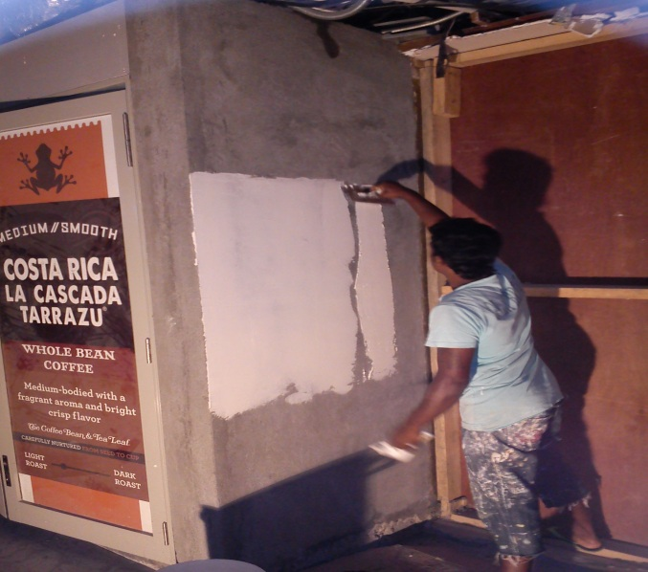

*Fig.28: applying pre-coat*

4.7.3 UNDER COAT OR BODY COAT

The primary coat and well bond with other paint coats and remain as an ordinary paint coat under coat covers. The most important thing of the under coat relates to the filling properties, color and support for the finishing coat. Heavy under coats are generally not allowed and hence suitable thinning agents must be mixed with paint to that the paint surface is quite thin and there are no excessive marks left after the application. The care has to be taken that there is no loss of adhesion in the case of old work. A good under coat should be such that after it’s drying, no clogging marks should be produced when it is rubbed with a sand paper. As this rubbing is essential before the application of any finishing coat. The tearing away of the film will result in damage, which is difficult to rectify. And also the color of the under coat should match with the finishing coat.

4.7.4 FINISHING COAT

The finishing coat attains the color that is required to be on the surface. The choice of the finishing material depends upon the position where this has to be applied. I.e. The type of finish required whether external or internal surface and whether glossy or matte and atmospheric condition etc. By using various colored paints, finishing can be done in different methods.

All these coats were important for giving a desired protection and a pleasing appearance.

**4.7.5 INSTRUMENTS USED FOR PAINTINGS**

* Grinder (with Diamond Wheel or Cup Wheel)
* Scraper
* Trowel
* Roller
* Brush

**4.7.6 SURFACE PREPARATION**

* The surface have to be dry and free from dust, dry salts, oil, grease and other sources of contamination.
* Smooth glossy surface is treated at with bonding agent.
* More than 5mm thickness of error on the walls must be plastered again.

**4.7.7 METHOD OF PAINTING**

* Before starting the painting work all surface should be free from dust & should be well cleaned.
* Then apply pre-coat using finishing trowel & Scraper (Applying have to be done directions, If the 1st coat and 2nd coat are applied in perpendicular directions.
* After that sand paper is used for rub well pre coat surface. (Using 500 w-1000 w flash light & 120-240 grit sand paper).
* Then it should be completed alignment of the edges and corners.
* Then apply paints 1st coat and patches work (using roller and brush).
* Finally apply paint 2nd coat.

# 4.7.8 TECHNICAL DETAILS

* Apply with roller, brush or air spray.
* Liquefy with a minimum of 20% volume for brush ability with clean water.
* Paint consumption: Theoretical – 15m2 per liter.
* Recoating interval – minimum 2 hours.
* Dry time – Touch dry, 10-15 minutes.

Hard dry, 1 hour.

**4.8 TILING**

**4.8.1 INTRODUCTION**

Tiling is the most popular floor finishing work. Floors and walls laid with ceramic tiles are becoming very popular these days. Different types of tiles are available in the market as ceramic, granite, marble etc. It should be selected the right tile for different uses and they should be laid by experienced workmen for good results. In my site, they used ceramic tile for bath rooms and panel room and granite tiles for other areas. As flooring can be an expensive item, much care should be taken in its selection and construction.

Generally these tiles are said with continuous joints in both directions as it will be easy to clean the joints. And tiles can be obtaining in wide range of patterns as well as sizes.

Tile floors are among the popular glamorous material for some time now. Over time, tile flooring has also become subject for customization and they are now offered in customized designs, special effects and distinct glazes.

The final selection of the floor and wall tile may be done after considering the following matters,

* It should be durable.
* It should be easy to clean.
* It should be fire resistance
* As far as possible it should be noiseless.
* It should have good appearance.
* There are should be a low maintenance cost
* It should be free from dampness

Ceramic Tiles

Ceramic tiles are made of natural organic materials and fired in very high temperatures. Ceramic technology can reproduce any color and any chromatic texture or design.

Granite Tile

Granite tiles have natural beauty, durability, resistance to heat and a sense of permanence etc.

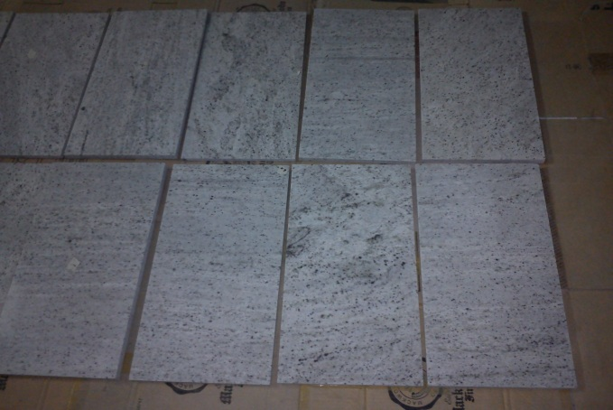

*Fig.29: Granite tiles*

**4.8.2 IMPORTANT CONSIDERING POINTS WHEN LAYING TILES**

* The surface should be very smooth and very clean.
* The first tile lay is the most important. If that tile is not positioned correctly and measured out from the borders of the installation area, whole installation will not be configured symmetrically.
* Put downward pressure on each tile and set each tile to the right level to match the adjacent tiles without it dropping to low and creating an uneven surface.
* Tiled work must be truly plumb, level and each course checked for straightness along both the top edge and face of the tiles.
* The surface on that the tiles are installed on floor or wall should be level.
* The joints in between the tiles should be about 2mm thick and filled in grouted and cleaned with water.

**4.8.3 FLOOR & WALL TILING**

**4.8.3.1 Surface Preparation**

Before laying the tile, it should be prepared the surface, where we are going to tile. First fill all cracks in the surfaces using approved crack filler. Then clean the floors of all remaining dust and loose particles, timber strips, concrete or mortar particles and pins like that. Then the floor should be washed to remove all dust. Then the tile bed can be laid down.

**4.8.3.2 Tile Bed**

**Floor:-**After cleaning the floor tile bed can be laid down. In our site we use 1:3cement: mortar bedding. Chemifix or cement dust is added before laying the bed as adhesive.

And after dry the bed completely it can be laid tiles.

Guide Points should be placed such that,

* Maintaining the Slope to the gulley.
* Maintaining the Floor Level Continuity
* Maintaining the Floor Level Drops
* Maintaining the Correct Door Opening sizes.

**Wall: -** Before plastering the dots (guide points) we have to consider about plumbing points. Wall is plastered with a cement mortar 1:3 to a thickness of about 12mm. When the plastering has hardened and is ready for the tile fixing, it is must be wetted.

Guide Points should be placed such that,

* Maintaining the verticality & even surface of the wall.
* Plumbing out lets are flushed to the tile surface.

Screed should be leveled, float & finished with a steel trowel, to a hard & even level surface and curing is done for a minimum of ten days.

Before laying the tile bed level pegs have to be arranging to keep the same level and in bathrooms to keep the slope according to the approved drawings.

**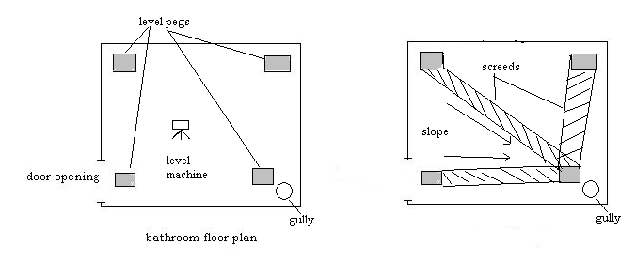***Fig.30: fixing level pegs*

**4.8.3.3 Tile Marking**

Marking for Tiling should be done on the tile bed according to the Tile Drawing, such that,

* Corners are not get fouled.
* Tile groves to be continued.
* Avoid having odd sized tile pieces at edges.

Thereafter Tiling can be commenced.

Main purpose of providing a tile line is to manage grooves in a tile line in both wall and floor. Normally a tile line is selected in the center of the tiling area.

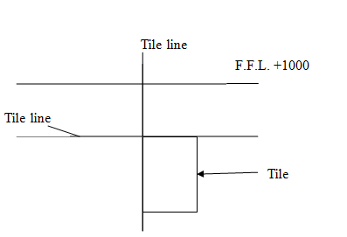

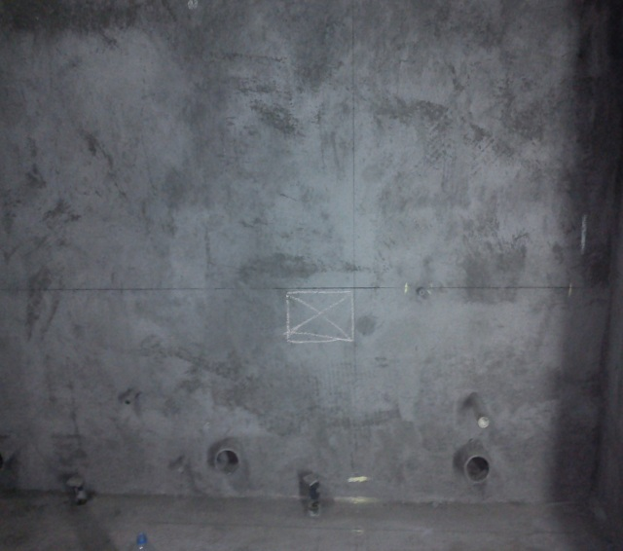 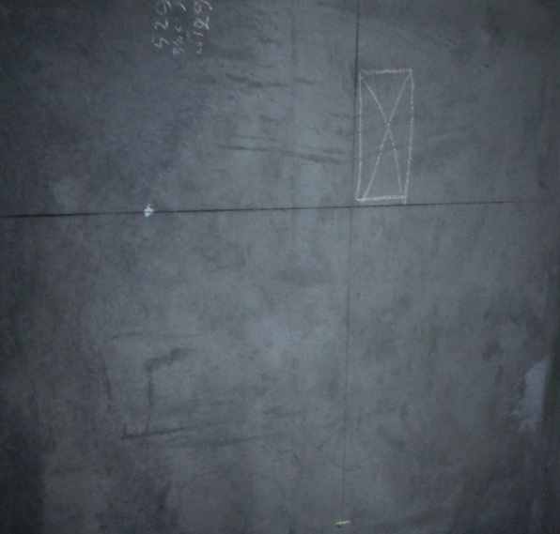

*Fig.31 & 32: tile marking*

**4.8.3.4 Applying Adhesive**

Cement mortar can be used as a low cost alternative to adhesives. Use the type of trowel on the adhesive. Spread ¼’ of a coat on the surface of one grid area and then use the notched side of the trowel to comb adhesive in to the standing ridges by holding the trowel at a 45-degree angle. After that remove the excess adhesive leaving a uniform, ridged setting bed.

Before starting the installing tiles, it should have to tack the batten under the tile line, so that the tile can be positioned against it. And then it can be started to tile, pressing the tile gently into the wall or floor until coming the adhesive squeeze out around the sides. And press spacers into each corner and hold a spirit level across the tiles to see if they form a flat surface.

Continue to tile and leave to dry fully before removing the batten.

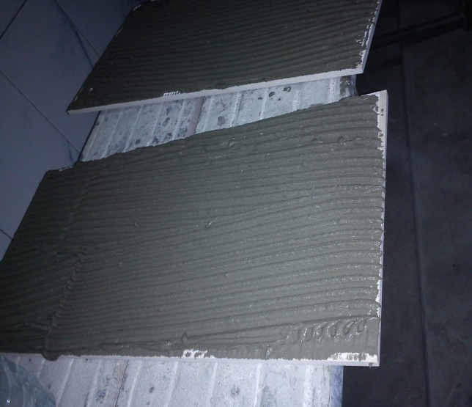 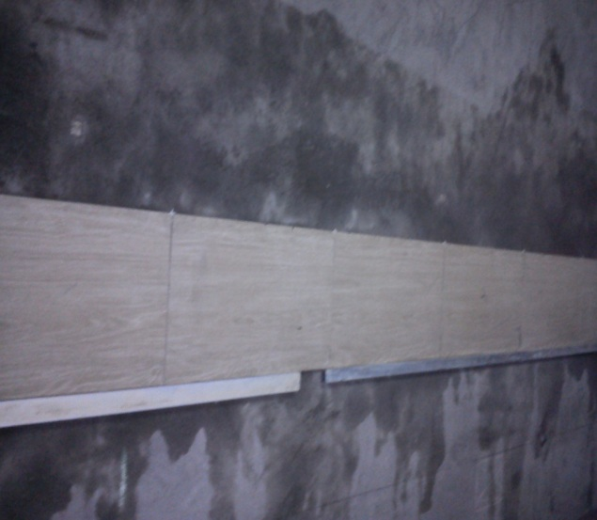

*Fig.33: Adhesive applied tile Fig.34: Tiles positioned against battens*

**4.8.4 GRANITE TILE INSTALLING**

Before starting the granite tiling, it should be cleaned the selected area. After removing the dust on the floor, spread the some adhesive like Chemifix (in my site, they used small quantities of cement & water as the adhesive) on those areas. Then put the motor (1:3cement: sand) and place some tiles in a row along one line without spacing between two tiles in same level. After adjusted them remove the tiles and put adhesive again (Chemifix or cement dust with water). Then keep the granite tile on it and press the tiles gently into the floor until coming the all tiles in same necessary level. It can be checked by using spirit level.

**4.8.5 INSTALLING THE TILE SKIRTING**

The final step of installing granite tile is to install the skirt. The idea of the skirt tile is to completely cover the edge and protect them from the top of the granite tiles.

This is the piece that will hide the rough edge of the granite. The skirt should exactly match the granite color.

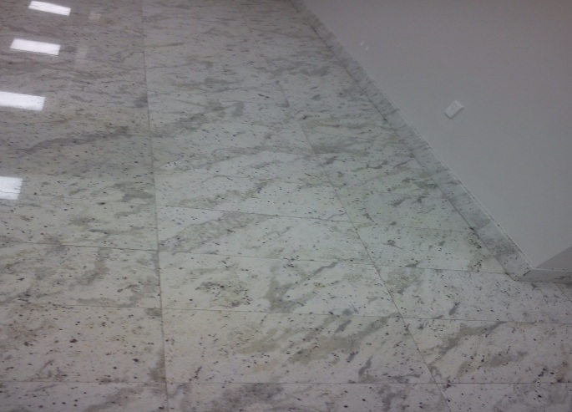 *Fig.35: Granite tiled floor*

# 4.8.6 GROUTING THE JOINTS

The surface (floor or wall) was cleaned before apply tile grout for joints, where tiles had been laid. Specially clean that groove in tiles which are available in various colors.

The tile grout mixture was made as follows:

* Clean water was added into powder and mix to thick creamy consistency. And about 15 minutes kept that mixture and before use it was remixed.
* Tile grout was compressed into the tile grooves, and after that surplus grout was removed from the face. Then after the tiles had been grouted wet the tilled surface firmly.

**4.8.7 EQUIPMENTS USED FOR TILING**

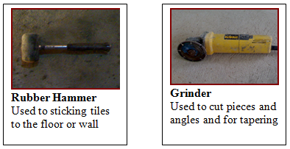

*Fig.36 & 37*

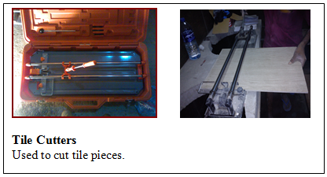

*Fig.38 & 39*

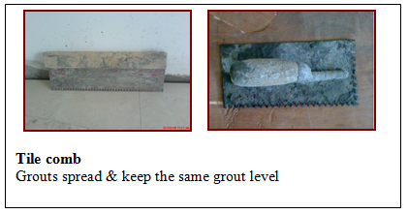

*Fig.40 & 41*

**4.9 EXPANSION JOINT**

**4.9.1 INTRODUCTION**

An expansion joint is a mid-structure separation designed to decrease stress on building materials caused in building construction by building movement like,

* Thermal expansion and contraction caused by temperature changes,
* Seismic events,
* Sway caused by wind etc.

It marks a gap through whole building because of the joint bisects the whole structure like walls, floors, roofs, planters, plazas, etc. In my site it makes only in the floor. This gap must be filled to restore the waterproofing, fire proofing, air barrier, roof membrane, trafficable surface and other functions of the building elements it bisects.

The expansion joint is more applicably encompasses the fact that building movement results in both compression and expansion of the material installed.

As an example, when a structure heats up, the building materials expand.  This causes the "expansion joint" to close down, thereby compressing the expansion joint system installed in the gap.

And conversely, when the temperature decreases, the materials cool causing the joint gap to open. The expansion joint material is required to contraction to follow the joint movement.

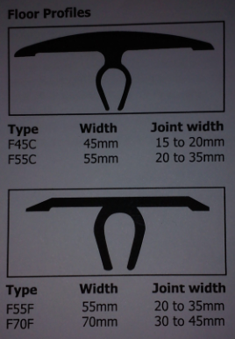

*Fig.42: two types of floor expansion joints. (In my site they used 2nd one)*

**4.9.2 INSTALLATION OF EXPANSION JOINTS**

First of all, it should be cut the small drain on the floor for expansion joint. In my site it is cut the drain 40mm depth and with 20mm width (half of depth) by using grinder. After cutting it, it should remove all dust and cleaned well. Then put the closed cell polyethylene joint backer rods in to the drain and push down. After that, apply primer (FR 200primer) on two walls of drain with using small brush. After few minutes, pour the sealant on the rod, until remaining the 10mm (half of the width of the drain) from the top level. In my site, they used mixture of FR 200 pouring grade black and FR 200 curing as the sealant. Then install the extruded aluminum joint cover plate. After installing that, it is wanted to keep some weights on it to slick well and it take 2-4 hours to stick well. (Data sheets of these are in appendix part)

**4.10 CEILING**

**4.10.1 INTRODUCTION**

Large public facilities such as airports, train stations and museums etc. are constructed the ceiling under these institutions to achieve this status it is necessary that the interior is eye-catching. It is very important that the architecture relies more on expressive forms and surfaces combined with state of the art technology, achieved with modern metal ceilings.

There are some beneficial properties of metal fiber ceiling.

* [Quality and durability](http://www.taim.info/en/advantages-of-metal-ceilings/quality-and-durability.php)  
  *Quality, Durability, Metal Ceilings*
* [Interior climate](http://www.taim.info/en/advantages-of-metal-ceilings/interior-climate.php)
* [Economy](http://www.taim.info/en/advantages-of-metal-ceilings/economy.php)
* [Hygiene](http://www.taim.info/en/advantages-of-metal-ceilings/hygiene.php)
* [Accessible Ceiling Void](http://www.taim.info/en/advantages-of-metal-ceilings/accessible-ceiling-void.php)
* [Environmental Friendliness](http://www.taim.info/en/advantages-of-metal-ceilings/environmental-friendliness.php)
* [Fire Protection](http://www.taim.info/en/advantages-of-metal-ceilings/fire-protection.php)
* [Design diversity](http://www.taim.info/en/advantages-of-metal-ceilings/design-diversity.php)
* [External Use](http://www.taim.info/en/advantages-of-metal-ceilings/external-use.php)
* [Surfaces](http://www.taim.info/en/advantages-of-metal-ceilings/surfaces.php)
* [Applications](http://www.taim.info/en/advantages-of-metal-ceilings/applications.php)

Normally, many of ceiling tiles are made of fiberboard, a mixture of fine fibers cut from wood and chemical binders. And also especial chemicals are added during this process to make fire-resistant tiles.

**4.10.2 METAL FIBER CEILING TILE**

There are metal fiber ceiling tiles that have different thickness like 8mm, 12mm, 15mm and 16mm. In my site, they used 15mm thickness tiles. And also, there are some features of the metal fiber ceiling tiles.

* Crisp and aesthetic look
* Eco-friendly and Biodegradable
* Provides superb acoustical solutions
* Light weight, easy to install and cut
* Dimensionally stable in high humidity
* Available in different designs and thickness
* Provides dual inhibition of mold/mildew and odor/stain-causing bacteria

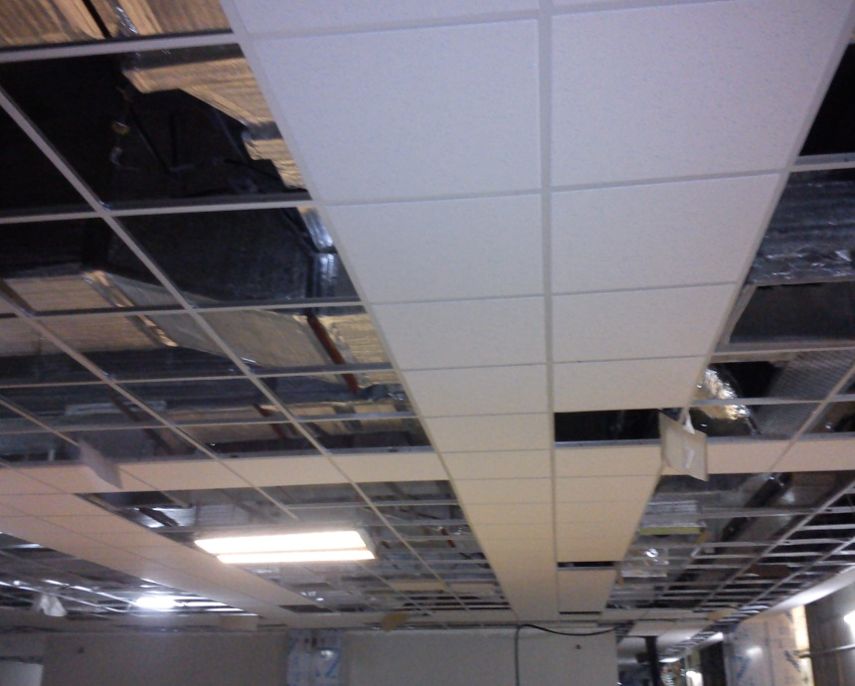 *Fig.43: ceiling*

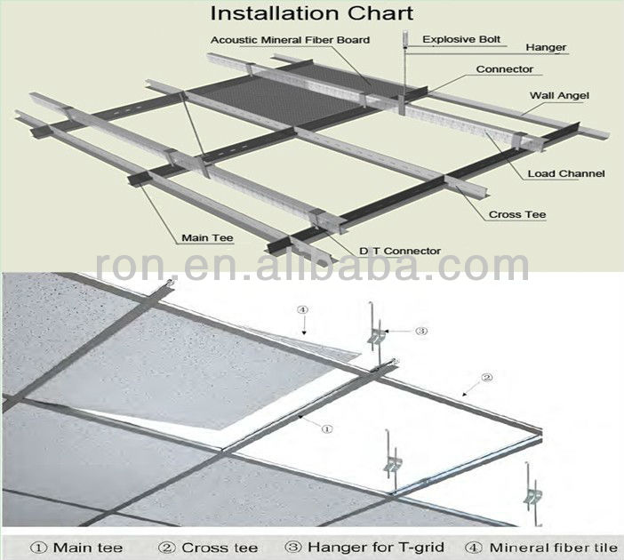

*Fig.44: metal fiber ceiling*

**4.11 SCAFFOLDING ARRANGEMENTS**

**4.11.1 INTRODUCTION**

Scaffolding is a temporary platform which is to do the upper works where can’t easily reach. It can be made by timber or steel. In past, bamboo trees are commonly used for scaffoldings. Steel scaffolding is easy to install and also safety. In my site it is used the steel scaffolding arrangements. The Scaffolding must be spacious & strong enough to support the men & materials during construction. There are some basic requirements of scaffolding. They are,

* They should be strong enough to carry the loads placed on them .
* The scaffold members should be kept in correct positions.
* Materials should not fall from the working platform.
* It should not bend or more in any direction

# 4.11.2 SCAFFOLD FITTINGS

Some commonly used scaffolding items are,

**Scaffolding Frame**

This is the main item of scaffolding. It is made by hollow GI sections of circular shape.

**Cross Bracings**

Cross Bracings is used for fixing of two scaffolding frames in a same level. It is consist of two steel circular hollow bars and they connected with pins. It is available in various sizes such as 1928mm, 1850mm etc.

**Joint pin**

This is used for fixing of two scaffolding frames where in two adjacent layers.

**Steel stage**

This is the flat form where on the scaffolding frames.

**G.I. pipes**

Considering of G.I. pipes, scaffolding can also be erected by using this pipes only. But it’s very difficult and they can used to support the scaffoldings. It is 50mm diameter which is used for scaffoldings.

**Clamps**

There are in two types.

* **Fix and Adjustable :-**

This type can be used, when there has to couple two G.I. pipes or scaffolding with a G.I. pipe, how produce a right angle to one another.

* **Free and Adjustable :-**

When considering this type, it can be used to couple two G.I. pipes with a G.I. pipe, how produce any angle.

**Jack base**

Two types of jack bases are available

* T tack base
* U tack base

When scaffolding has to be erected on uneven surface, each two-type help for maintaining the level of the scaffolding sets

**4.12 SAFETY**

In any working site, safety of the occupants is a necessary factor to concern. In case of construction industry, the workers are more vulnerable to face accidents and needs taking actions in making it less by taking proper precautions for safety.

**4.12.1 SAFETY EQUIPMENTS USED IN THE SITE**

There are many safety equipments that are very necessary in each type of construction site. Some of them are;

**Safety Helmet**

It should be worn safety helmet to protect our head from the some shock load. This helmet made by hard plastic shell and chin guard. We should be worn the safety helmet with that chin guard by fixing correctly. 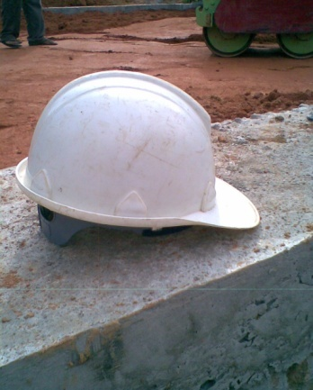

*Fig.45*

**Safety Shoes and Safety Boots.**

It can be safe the feet by wearing safety shoes from the sharp metal pieces, hot hazards, accident, chemical hazards also shock load on the foot. There is a metal cover in the toe of the shoe that protects our fingers from the heavy loads. Also, these shoes resist to the water, electricity and we can walk on the oily floor without risking. Normally safety boots are used when concreting at the site.

**Head Shield/Hand Shields**

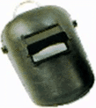 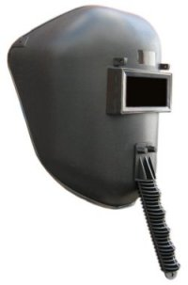

*Fig.46*

It is used in the welding. Worker can protect those eyes from the arc.

**Earplugs**



*Fig.47*

They are used to protect ears from the loud sounds. When workers are working with the machinery, this needs to wear ear protections.

**Eye Protectors (Goggles)**

*Fig.48*

When workers are grinding a metal part they should wear an eye protecting goggle. If not our eyes may be damaged due to striking small metal parts.

**Gloves**

Gloves are used to protect the hand. There are various types in site.

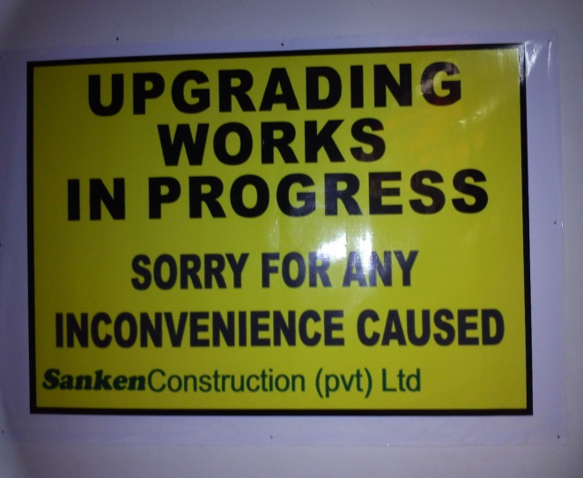 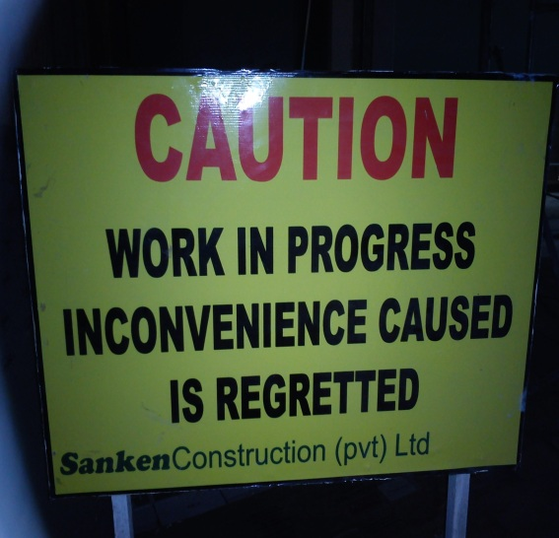

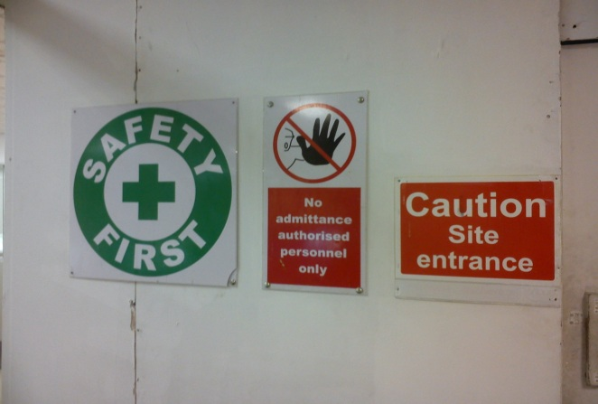 *Fig.49: Some banners that shows at site*

**5.0 CONCLUSION**

In conclusion, there are many things that I have experience and learnt during the three month of internship of a proposed transit/duty free shopping area expansion at Bandaranayake International Airport, Katunayake in Sri Lanka. By working this site provided me with good knowledge about construction. The whole training period was very interesting, instructive and challenging.

In my second training, I got an opportunity to work with talented project manager who has wide experience, site engineers and store keepers. I have got a lot of experience by working with skilled masons, unskilled labours, and machine operators.

In here, I was able to gain experience and confidence to face the challenges, when it will be practicing as young civil engineer in future, through my internship. I believe that, I have achieved a lot of things that I expected from the internship. And I am well satisfied with my training.

**6.0 REFERENCES**

1. <http://www.sankenconstruction.com/>
2. <http://www.wikihow.com/Tile-a-Bathroom-Floor>
3. <http://www.todayshomeowner.com/how-to-install-a-granite-tile-countertop/>
4. <http://www.dechom.com/ceiling-tile.html>
5. <http://en.wikipedia.org/wiki/Expansion_joint>
6. <http://en.wikipedia.org/>

**7.0 APPENDIX**

1) The floor layout before demolition

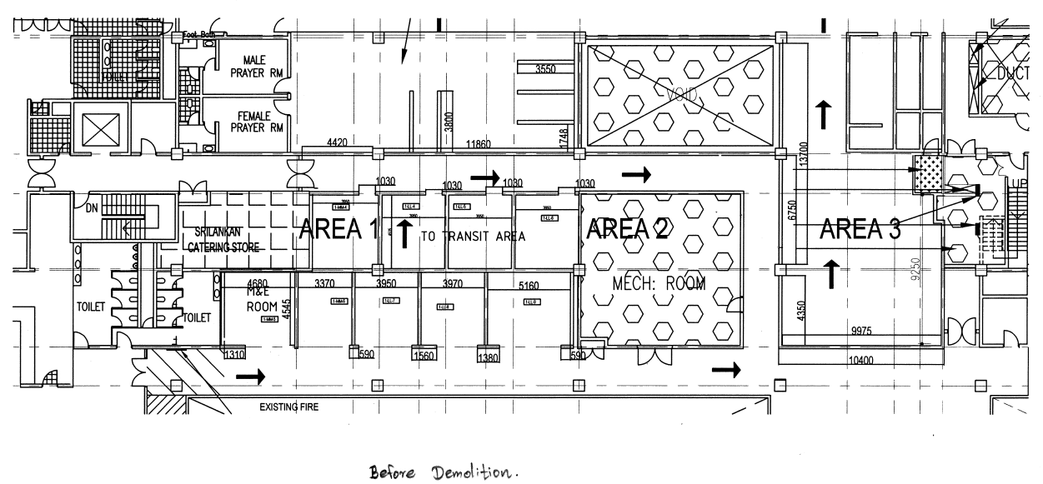

2) Construction areas (Area 1, Area 2, Area 3 and Area 4) or Granite tiling area

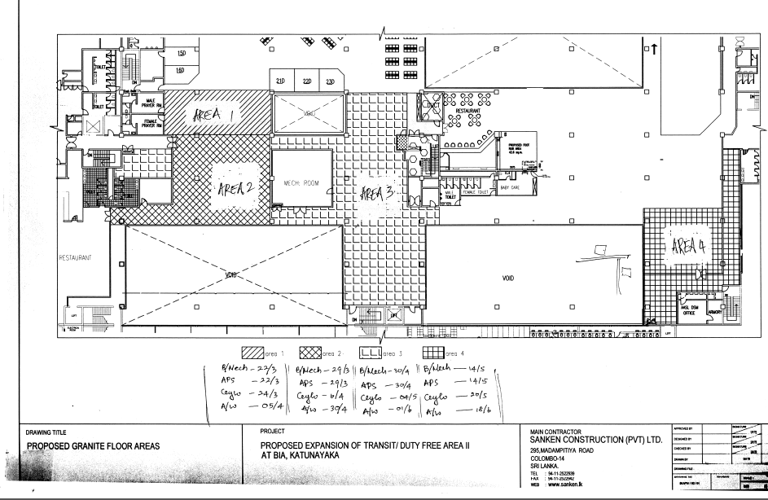

3) Ceiling height and grid layout

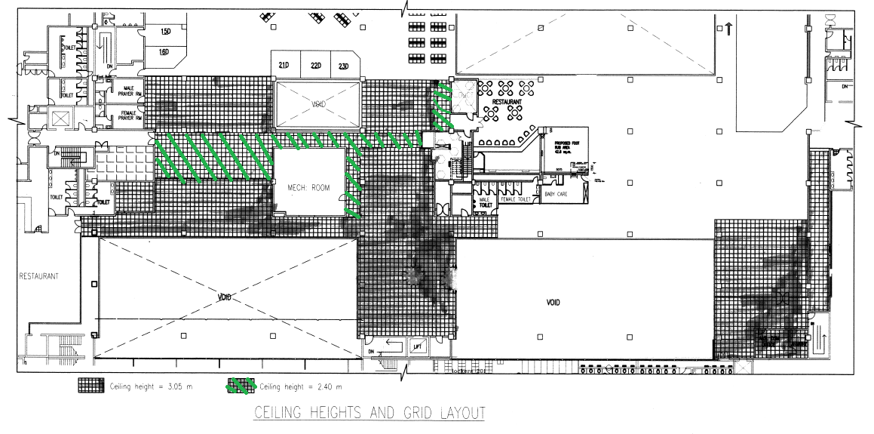

4) Mineral fiber ceiling tile layout

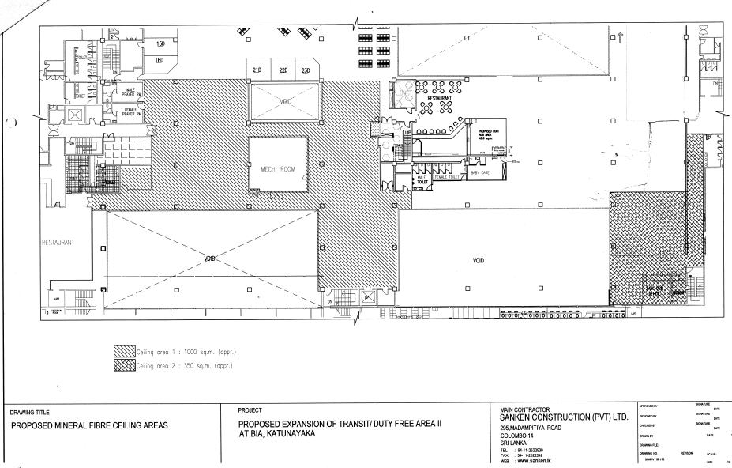

5) The measurement sheet of painting area

